Preparing for Transition from Key Stage 4 to Key Stage 5
Subject | Qualification
Economics | A Level
Recommended Reading Materials | Recommended Websites
- OCR A Level Economics (4th Edition)  - OCR A Level Economics Student Book (AS) Summary - Susan Grant  - A Level Economics (5th Edition) - Alain Anderton  - OCR A Level Economics Student Guide 3: Microeconomics 2 - Sam Dobin  - OCR A Level Economics Workbook: Microeconomics 2 - Terry Cook | - www.tutor2u.net - tutor2u  - www.studywise.co.uk - StudyWise  - www.ocr.org.uk - OCR  - www.economicsonline.co.uk - Economics Online  - www.ezyeducation.co.uk - Ezy Education
Preparation Tasks | Recommended Research
- Task 1:  Identify the nature and purpose of an economic activity  - Task 2:  Explain how resources are used to produce goods and services (e.g. non-renewable, renewable, materials, water and animals)  - Task 3:  Analyse the role of the following economic agents:  - Producers  - Consumers  - Governments | - OCR A Level Economics (4th Edition)  - www.tutor2u.net - tutor2u  - www.tutor2u.net - tutor2u  - www.economicsonline.co.uk - Economics Online  - www.study.com - Study.com  - www.youtube.com
Recommended trips or visits this Summer
- Bank of England
- Federal Reserve Bank of New York
- Mansion House
- The Gherkin
- The Crystal
- The London Stock Exchange

Tasks to Complete
- Define a free (a free good is one without a market-determined price) and an economic good. Refer to scarce goods, infinite wants, needing to make a choice and the economic problem. Also, that free goods have no opportunity cost (define the term) but that economic goods do have an opportunity cost.

- You should aim to make a clear distinction between the free and the market priced good. This should enable you to include the following key terms:
- Scarcity
- Choice
- Allocation of resources
- Opportunity Cost
- How economic systems make their choices
- Private and Social costs

- Explain what the production possibility curve shows, using a diagram to illustrate your answer. Refer to the assumptions that are made when drawing the curve. Illustrate points inside the curve means unemployed resources or inefficient production. Explain a shift occurs due to economic growth

Example of Production Possibility Frontier:

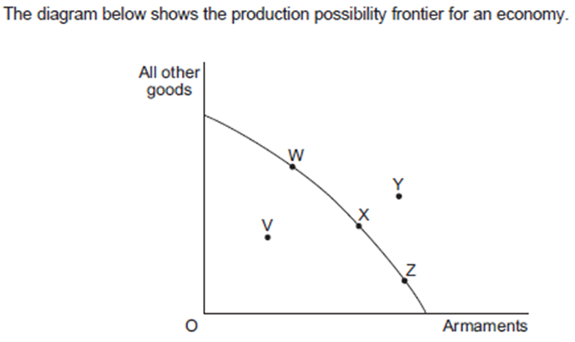

- Define economic growth and explain how it can happen, e.g. increase in the quantity of resources, increase in the quality of resources or technological progress. Giving examples of each

- Evaluate the different objectives of economic agents in an economy

