Subject | Qualification
Business | A Level
Recommended Reading Materials | Recommended Websites
- How Business Works - Dorling Hindersley  - The Young Entrepreneur's Guide to Starting and Running A Business - Steve Mariotti  - Coronavirus – A visual guide to the economic impact  - https://www.bbc.co.uk/news/business-51706225 - BBC News  - Coronavirus' business impact: Evolving perspective | McKinsey  - https://www.mckinsey.com/business-functions/risk/our-insights/covid-19-implications-for-business - Mckinsey & Company | - Reuters  - Bloomberg  - BBC Business News  - Financial Times  - Wall Street Journal  - Business Review  - The Economist
Preparation Tasks | Recommended Research
- Study a business that is counter-cyclical, i.e. sales are rising, while many business’ sales are falling. What is the key to their success? How can they maintain and build on that success?  - Design a marketing campaign for a new good or service. How would you advertise and promote that good? How would you price it? Which method of selling the product would you use, e.g. retail stores, online selling? Justify your answers | - https://www.bbc.co.uk/news/business-51706225 - BBC News  - https://www.mckinsey.com/business-functions/risk/our-insights/covid-19-implications-for-business - Mckinsey & Company  - Coronavirus: Six things that are booming in sales  https://www.bbc.co.uk/news/business-52066454 - BBC News  - How to run a successful marketing campaign https://paysimple.com/blog/how-to-launch-a-marketing-campaign-for-your-small-business-in-7-easy-steps/ - Pay simple
Recommended trips or visits this Summer
- Bank of England Museum
- City of London make a note of the names of the different international banks. Where are they from?
- Sky Garden, Fenchurch Street
Tasks to Complete
Task 1 – Marketing: Developing your own product launch:
To be successful businesses need effective marketing to achieve their business objectives. This will include determining the needs and wants of its existing and potential customers and delivering the desired goods or services more effectively and efficiently than its competitors. Businesses need to know what it is they are selling, the price of their goods or services, who they are selling to, where it is being sold and why people buy that type of product or service.

Part 1
Select a product of your choice from any business and examine ways that it could be further improved. The improvements should meet the demands of its target market, while also making it competitive in the marketplace.

Part 2
Decide on five ways that you might advertise and promote this newly modified product. Justify each of your choices.

Part 3
Describe how you would give a sales pitch that you would present to the Company Director in favour of launching this newly modified product onto the market. You could prepare the sales pitch with Power point slides. Give an analysis and evaluation of why you think it would be successful and if you had more time how would you try to improve it?

Task 2 – Finance: Investing in a business:
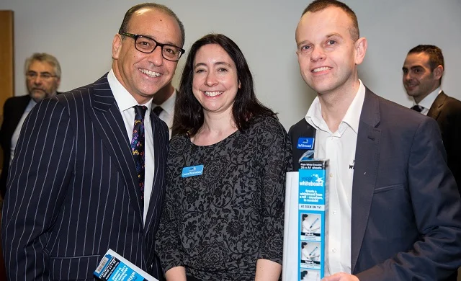
Watch this clip from Dragon’s Den on the Magic Whiteboard. Would you invest in this business?

The Magic Whiteboard (series 6) - Neil and Laura Westwood
https://www.digitalspy.com/tv/reality-tv/a824197/dragons-den-products-inventions/
Part 1
Explain the positive aspects of investing in the business

Part 2
Explain the negative aspects of investing in the business

Part 3
Your decision (give your judgement, would you invest in this business? Why/why not?)

